Bi-communication lis protocol definition
Catalog 3
Chapter 1 overview 4
1.1 Purpose 4
1.2 Who need read 4
1.3 Range of application 4
Chapter 2 Lis protocol of worksheet 5
2.1 Work mode 5
2.2 Worksheet name format 5
2.3 Content of worksheet 5
2.4 Definition of worksheet information 6
2.4.1 Definition of information head(MSH) 6
2.4.2 Definition of patient information part(PID) 6
2.4.3 Definition of hospitalized information(PV1) 7
2.4.4 Definition of Specimen’s information(OBR) 7
2.4.5 Test mode part information(OBX) 9
2.4.6 Definition of information tail(MSE) 9
  - Example of worksheet information 9

Chapter 1 Overview

Purpose
This instrument is illustrate how to make the bi-communication LIS function come true.

Who need read this instrument
Lis system engineer and who related.

Range of application
Suitable to PluScope software.

Chapter 2 LIS protocol of worksheet

2.1 Work mode
According to work process, worksheet have three mode:
Receive worksheet mode(download mode)
Require worksheet mode(require mode)
Input worksheet by manual(manual mode)
This instrument is for the first mode； That’s mean need lis system download the worksheet to a certain folder；

2.2 Worksheet name format
Each specimen have a worksheet and name format should be as below：
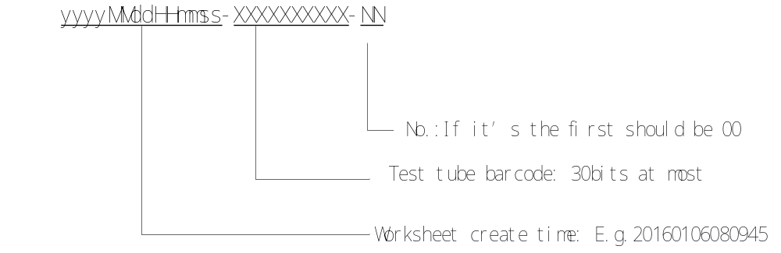
There have three parts of the worksheet: date and time; barcode and No. they are split by hyphen (-)
No.: Use to distinguish the worksheet share same barcode but download many times. If one barcode worksheet first download the No. should be 00, then second or third time will be 01 and 02. This is use for urinary three cups test, that situation will be have three specimen but barcode of them is same.
E.g.: One specimen’s barcode is 123456789 need be test on 1 june 2016, the first download worksheet should be name as 20160106080945-123446789-00
The second download should be name as: 20160106080950-123456789-01
The third download should be name as: 20160106080955-123456789-02

2.3 Content of worksheet
Worksheet should be content below information:
Specimen information:Barcode/Sampling time/Submission time/Submission person and so on.
Test items: test mode.
Patient information: Patient name/sex/age and so on.
Hospitalized information: medical record No./BedID/Health insurance No./Submission department/Patient ward and so on.

2.4 Definition of worksheet information
Worksheet information content 6 parts: Information head(Required)/ Patient information(Optional)/ Hospitalized information(Optional)/ Specimen information(Required)/ Test mode(Required)/ Information tail(Required)

2.4.1 Definition of information head (MSH)
MSH|LIS|2016010612111124|EH-v1.0|UTF-8<CR><LF>
Information head begin as MSH, split 5 parts by vertical bar(|)
Part one: MSH Fixed field
Part two: Resource of worksheet, Fixed as ‘LIS’
Part three: date and time, the format is ‘yyyyMMddhhmmss’ should be 14 characters length.
Part four: Version No. fixed as EH-v1.0
Part five: Code format, fixed as UTF-8
<CR><LF> carriage return and end.

2.4.2 Definition of patient information part (PID)
PID – Patient Identification be used transfer and identify patient information, it include patient identify and statistics information.
Specific as below:
Table 1 PID part structure definition
Element | Name | Usage | Description
PID-1 | Set ID - PID | O | Series number
PID-3 | Patient Identifier List | O | Patient identifier list, used as medical institutions to identify each patient.
PID-5 | Patient Name | O | Patient name
PID-7 | Date/Time of Birth | O | Birth date
PID-8 | Administrative Sex | O | Sex: 0-male；1-female，2-unkown
* Usage：R mean this part is required，RE mean can be null，O mean this part is optional；
PID’s text format as below：
PID|x| Description|Value<CR><LF>
This section contents 4 parts, split by vertical bar(|)
Part one: PID mean patient information fixed character.
Part two: x is number, For example X=1 mean PID-1
Part three: Description is the description of this part.
Part four: Value is the specific content of this part.
<CR><LF> carriage return and end.

2.4.3 Definition of hospitalized information (PV1)
Specific structure as below:
Table 2 PV1 part structure definition
Element | Usage | Description
PV1-1 | O | Series number use to locate which information of the PV1
PV1-2 | O | Patient classification: be used for medical insurance No. and medical record No. format is medical insurance No.^medical record No.; If each of them don’t have can use a space to replace. For example,if don’t have medical insurance No. it can be as ‘ ^medical record No.’ ; If both of them don’t have then this part can be omit.
PV1-3 | O | Assigned patient location; show as submission department^patient ward^bedID; If one of them don’t have can be omit. For example, don’t ahve patient ward information can be show as submission department^^bedID.
PV1-18 | O | Patient type；
PV1-21 | O | Charge type；
* Usage：R mean this part is required，RE mean can be null，O mean this part is optional；PV1 Text format as below：
PV1|x| Description|Value<CR><LF>
This section content 4 parts, split by vertical bar (|).
Part one: PV1 mean hospitalized information fixed character
Part two: x is number. For example x=1 mean PV1-1.
Part three: Description is the description of this part.
Part four: Value is the specific content of this part.
<CR><LF> carriage return and end.
Notice: The information in PV1-3 is split by ‘^’ if some information is lack can use a space to replace. For example:
Submission department is internal medicine department, patient ward is 2, outpatient don’t have bedID so it can be show as ‘internal medicine department^2^’

2.4.4 Definition of Specimen’s information (OBR)
Specimen information part, be used for describe specimen’s characteristics include specimen’s ID/ barcode/ sampling time/ submission time/ submission doctors and so on.
Specific structure as below:
Table 3 OBR part structure definition
Element | Name | Usage | Description
OBR-1 | Set ID OBR | O | Series number use to locate which information of the PV1
OBR-2 | Placer Order Number | R | Specimen ID unique for each specimen. Be used for barcode.
OBR-3 | Filler Order Number | O | It is used for sample ID in Specimen test result information.
OBR-6 | Request Time | O | It’s submission time：yyyyMMddhhmmss；
OBR-10 | Collector Identifier * | O | It’s mean submission person.
OBR-13 | Relevant Clinical Info. | O | It’s mean other diagnostic information.
OBR-14 | Specimen Received Date/Time * | O | It’s mean sampling time：  yyyyMMddhhmmss；
* Usage：R mean this part is required，RE mean can be null，O mean this part is optional；
OBR Text format as below：
OBR|x| Description|Value<CR><LF>
This section content 4 parts split by vertical bar(|).
Part one: OBR mean specimen’s information fixed character.
Part two: x is a number, For example if x=1 mean OBR-1.
Part three: Description mean this part’s function description.
Part four: Value is the specific content of this part
<CR><LF> carriage return and end.

2.4.5 Work mode (OBX)
OBX section use to describe whether test chemistry or sediment.
Table 4 OBX section structure definition

Element | Name | Usage | Description
OBX-1 | Set ID-OBX | O | Series number use to locate which information of the OBX
OBX-3 | Observation Identifer | R | Test items select it’s required information.  Use to describe Test Mode，Value include below options：  - Chemistry  - Sediment  - Chemistry+Sediment
* Usage：R mean this part is required，RE mean can be null，O mean this part is optional；
Notice：OBX-3 Test mode
Chemistry---Only test chemistry；
Sediment---Only test sediment；
Chemistry+Sediment --- Test chemistry and sediment both；
OBX|x| Description|Value<CR><LF>
This section contents 4 parts split by vertical bar(|).
Part one: OBX mean work mode information fixed character.
Part two: x is a number, For example if x=1 mean OBX-1
Part three: Description mean this part’s function description.
Part four: Value is the specific content of this part
<CR><LF> carriage return and end.

2.4.6 Definition of information tail (MSE)
Text format
MSE<CR><LF>
This section just have one part.
MSE –Fixed character
<CR><LF> carriage return and end.

2.5 Example of worksheet information
Worksheet example:
MSH|LIS|20160105084514|EH-v1.0|UTF-8
PID|1|Series number|120124
PID|5|Patient name|John
PID|7|Patient’s birth day|19880105
PID|8|Sex|0
PV1|2| medical insurance No.^medical record No.|^15782
PV1|3|submission department^Patient ward^BedID|Internal medicine department^2^1012
OBR|1|Series number|1201242
OBR|2|test tube barcode|12465114612
OBR|3|sample ID|0056
OBR|6|sampling time|20160106112210
OBR|10|Submission person|Steve
OBR|14|submission time|20160106112314
OBX|3|work mode| Chemistry+Sediment
MSE

